# Section 1: Consortium Information

Butte-Glenn Adult Education Consortium

**Consortium Primary Contact:**

**Jennifer Macarthy**

Butte College

Director – Career and Technical Education Grants and Regional Projects

530-895-2862

macarthyje@butte.edu

Submitted:

6/5/19

Table of Contents

Section 1: Consortium Information i

Section 2: Comprehensive Regional Three-Year Plan 1

2.1 Executive Summary 1

2.2 Pre-Planning Assessment 3

Table 1. Regional Service Providers 5

Table 2. Funding for Adult Education Programs and Services 7

2.3 Community Need and Customers 8

2.4 Identifying Goals and Strategies 11

Figure 1. Roadway to Success - Consortium 12

Figure 2. Roadway to Success – Community 12

Figure 2. Roadway to Success – Participants 13

Table 3. Goal, Objectives, Implementation Measures, and Progress Indicators 14

2.5 Piloting and Implementation 18

Appendix 19

Appendix A – Butte-Glenn Consortium Accomplishments 19

Appendix B – Self Assessment Scoring Sheet 20

# Section 2: Comprehensive Regional Three-Year Plan

## 2.1 Executive Summary

Impact from Previous Planning Period

During 2016-2019, the Butte-Glenn Adult Education Consortium made great strides toward the development of a coordinated, far-reaching, and collaborative Adult Education model. In addition, each of the individual members also completed positive organizational and programmatic improvements. For a full summary of the consortium’s accomplishments, please see ***Appendix A***. A sample of the primary accomplishments include:

* Assistance to Paradise Adult Education, and the students they serve that were impacted by the Camp Fire,
* Coordinated assistance with data and reporting through the shared cost of a submit matter expert housed at Oroville Adult Education.
* Facility remodels and expansions: Glenn County Adult School expansion, Butte County Office of Education CTE facility remodel, Oroville Adult Education’s physical expansion into Chico, and Hamilton Adult School’s expanded facility.

Goals & Key Indicators

During the 2019-2022 planning period, the Butte-Glenn Adult Education Consortium will continue the positive momentum from the previous planning period, and focus on increased levels of coordination, expanded programs/services, and increased overall success rates for adult education students in Butte and Glenn Counties. Please see ***Section 2.4*** for details on the goals, objectives and implementation measures for the 2019-2022 planning period. The consortium analyzed each goal to determine how it aligns with the AB 104 outcomes: (1) improved literacy skills, (2) completion of high school diplomas or their equivalents, (3) transition into postsecondary study, (4) completion of postsecondary certificates, degrees, or training programs, (5) placement into jobs, and (6) improved wages. The following summarizes the goals, AB 104 outcomes, and progress indicators as developed by the consortium:

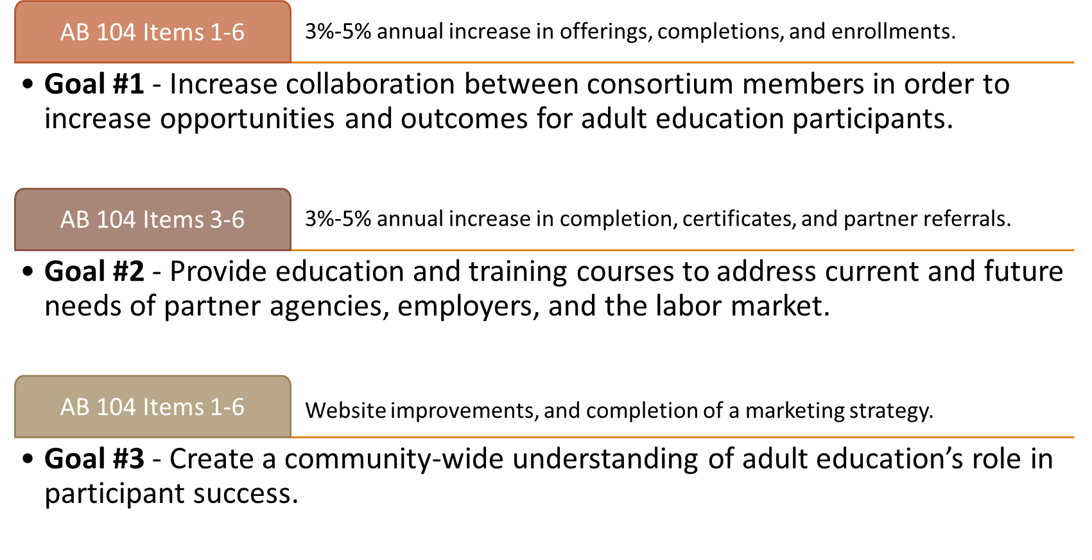

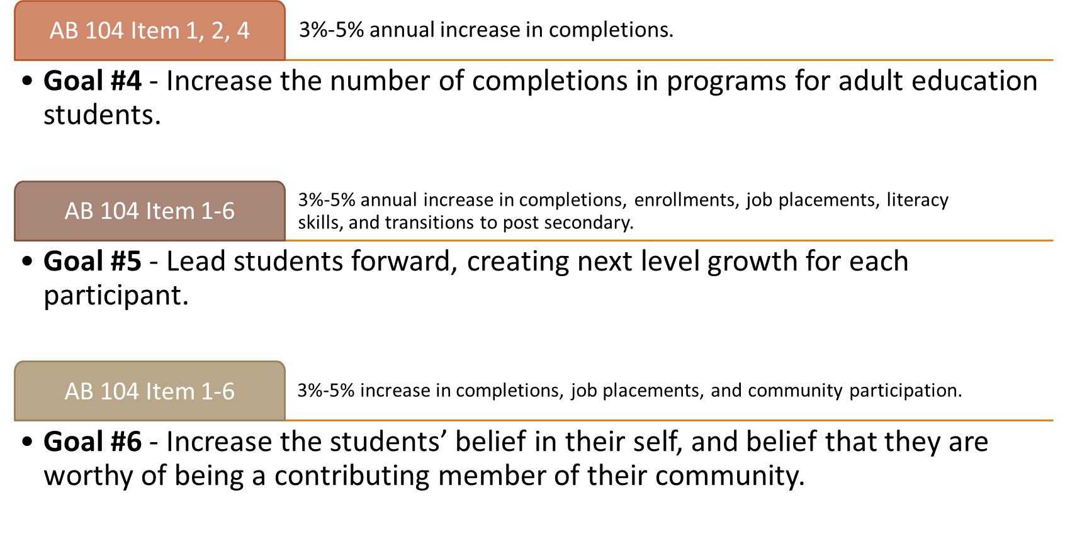

## 2.2 Pre-Planning Assessment

The Pre-Planning Assessment that was completed by the consortium included an analysis of regional adult education partners and the programs that they offer, a mapping of the Butte-Glenn Consortium Members’ programs and funding sources, and a self-assessment that was completed by each of the consortium members. In addition, the consortium evaluated other local programs to determine how their efforts align with others within the region.

Regional Adult Education Partners

In order to gain a broader understanding of the current state of adult education within Butte and Glenn Counties, the members developed a detailed list of the all of the providers of adult education services/programs in the region as it relates to: Career and Technical Education, Adult Basic Education, Adult Secondary Education, and English as a Second Language (***Table 1***).

Funding for Adult Education

The Butte-Glenn Consortium is fortunate to receive funding from a variety of different sources. That being said, the consortium is still faced with rising costs that are not in full alignment with available funding. It is due to this fact that the consortium is looking into more opportunities for collaboration, and opportunities to expand programs and services related to the community need. Information of Consortium Member funding can be found in ***Table 2*** below.

Self-Assessment

The Butte-Glenn Consortium participated in a process to examine the consortium’s effectiveness in the following areas: capacity, connection, entry, progress, and completion/transition. The Self-Assessment Tool provided an opportunity to begin important conversations about the quality of collaboration and impact on the region. The results can be found in ***Appendix B***. The self-assessment questions were scored as follows:

**Butte-Glenn Adult Education Consortium**

|  |  |  |
| --- | --- | --- |
| **Member Organization** | **Website** | **New/Emerging Programs** |
| Butte-Glenn Community College | [www.butte.edu](http://www.butte.edu/) | Occupational & Life Skills; Healthy Aging & Living |
| Butte County Office of Education | [https://cte.bcoe.org](https://cte.bcoe.org/) | Construction, Culinary, Manufacturing |
| Glenn County Office of Education | [www.glenncoe.org/Departments/Glenn-Adult-Program](http://www.glenncoe.org/Departments/Glenn-Adult-Program) | Truck Driving |
| Hamilton Unified School District | [www.husdschools.org](http://www.husdschools.org/) | Floral Design, Fork Lift Operator |
| Oroville Adult Education Career & Technical Centers | [https://orovilleadulted.com](https://orovilleadulted.com/) | Certified Nursing Assistant, Emergency Medical Technician, Electrocardiogram (EKG) Technician |
| Paradise Unified School District | [www.pusdk12.org](http://www.pusdk12.org/) | Adult Basic Education, Adult Secondary Education |

### Table 1. Regional Service Providers

|  |  |  |  |  |
| --- | --- | --- | --- | --- |
| **Organization** | **Career & Tech Ed.** | **Adult Basic Ed.** | **Adult Secondary Ed.** | **English as a Second Language** |
| Advance North State | **X** |  |  |  |
| Butte Community Based Coalition | **X** |  |  |  |
| Butte County Office of Education Leadership Development | **X** |  |  |  |
| Butte County Alternative Custody |  |  | **X** |  |
| Butte County Library |  | **X** |  | **X** |
| Butte County Probation |  |  | **X** |  |
| Cal JAC - Fire Apprenticeship | **X** |  |  |  |
| California Conservation Corp | **X** |  | **X** |  |
| California Human Dev. | **X** |  |  |  |
| Contracted Program Providers | **X** |  |  |  |
| CTE Online | **X** |  |  |  |
| Far Northern | **X** |  |  |  |
| Farm Worker Camp |  |  |  | **X** |
| Glenn County Alternative Custody |  |  | **X** |  |
| Glenn County Library |  | **X** |  | **X** |
| Glenn County Probation |  |  | **X** |  |
| High Schools | **X** |  | **X** |  |
| Jesus Center |  |  | **X** |  |
| Jordan's Crossing |  |  | **X** |  |
| NCCC/Glenn HHSA | **X** |  |  |  |
| NORTEC/AFWD | **X** |  |  |  |
| Private Co. Partnership | **X** |  |  |  |
| Salvation Army |  |  | **X** |  |
| Strong Workforce Program | **X** |  |  |  |
| Torres Shelter |  |  | **X** |  |
| Tri-Counties Rehab |  |  | **X** |  |
| Work Training Center | **X** | **X** |  |  |

### Table 2. Funding for Adult Education Programs and Services

|  |  |  |  |  |  |  |  |  |  |  |
| --- | --- | --- | --- | --- | --- | --- | --- | --- | --- | --- |
| **Member Organization** | **AEP** | **WIOA II** | **Course Fees** | **District Funds/ County Office of Ed** | **Far Northern** | **State Library** | **Donations** | **Cal Works** | **County Sheriff** | **Private Contracts** |
| Butte College |  | **X** |  | **X** | **X** |  |  | **X** | **X** | **X** |
| Butte County Office of Education | **X** | **X** | **X** | **X** |  |  | **X** |  |  | **X** |
| Glenn County Office of Education | **X** | **X** | **X** | **X** | **X** | **X** | **X** |  |  | **X** |
| Hamilton Unified School District | **X** | **X** | **X** | **X** |  |  |  |  |  | **X** |
| Oroville Unified High School District | **X** | **X** | **X** | **X** |  |  |  | **X** |  | **X** |
| Paradise Unified School District | **X** |  | **X** | **X** |  |  |  |  |  |  |

## 

## 2.3 Community Need and Customers

In an effort to better understand the needs of the community, the Butte-Glenn Adult Education Consortium was provided access to a variety of existing resources including:

* LaunchBoard Adult Education Pipeline
* North/Far North Regional Consortium website/studies
* Northern Central Counties Consortium (NCCC) website/studies
* Northern Rural Training and Employment Consortium (NoRTEC) website/studies

The consortium determined that they were interested in a specific report that detailed the Butte-Glenn regional labor market and occupational outlook. The consortium collaborated with NoRTEC, one of the local Workforce Development Boards, to create an analysis that was based on data, but that also included a qualitative analysis of the data. The quantitative data for the profiles include a geographic overview, demographic and labor force characteristics, industry analysis, occupation analysis, and labor force data. For the profile, data was collected and analyzed data from Economic Modeling Specialists Int’l. (EMSI), U.S. Census Bureau, the U.S. Bureau of Labor Statistics, and various other state sources.

The three documents developed for the consortium include:

1. Glenn County Labor Market Profile & Industry Analysis,
2. Butte County Labor Market Profile & Industry Analysis, and
3. Occupational Outlook Report for Butte & Glenn Counties.

These reports will be posted on the consortium website. The reports, in combination with the other data resources, will be evaluated by the consortium again in the Fall when the development of new courses is discussed, and in the Spring when programs are evaluated. Due to the size of the reports, they are not included as an appendix to this document, but will be available on the Butte-Glenn Adult Education Consortium website ([www.butteglennadulted.org](http://www.butteglennadulted.org) ). The following provides a snapshot from the Occupational Outlook Report, providing an example of the level and type of information provided in the report as it relates to the Healthcare Industry – Direct Patient Care Occupations.





## 2.4 Identifying Goals and Strategies

After completing the Pre-Planning Assessment, and evaluating Community Need, the Butte-Glenn Consortium worked to develop a logic model for success as it relates to the Consortium, Adult Education Participants, and the Community. The model is referred to as the “Roadway to Success”. To develop the model the consortium members determined the inputs (clients) in each of the area, and then discussed what success would look like for the identified clients. Next, the group discussed what could be considered as barriers to success, and what could be considered as thoroughfares to success. The Roadway to Success models (***Figures 1-3***) were then utilized to further develop goals, objectives and implementation measures as they relate to the Consortium, Adult Education Participants, and the Community.

***Table 3*** details the goals, objectives, implementation measures, and progress indicators for the Butte-Glenn Adult Education Consortium for the period 2019-2022.

### Figure 1. Roadway to Success - Consortium

|  |  |  |  |
| --- | --- | --- | --- |
| **INPUT (CLIENT)** | **BARRIERS** | **THOUROUGHFARES** | **OUTPUT (SUCCESS)** |
| Butte College | Work in isolation | Communication | Sharing Resources |
| Butte County Office of Education | Outside entities | Trust | Programs based on need (data) |
| Glenn County Office of Education | Awareness of member programs | Collaborative marketing | Collaboration (program development/offerings) |
| Hamilton Unified | Ability to cross populate students & offerings | Central hub for information | Cross-Promotion |
| Oroville Adult School | Transportation | Easy enrollment process (SIS) | Regional Recruitment |
| Paradise Unified | Creation of collaboration plan |  |  |
|  | Ability to share funding allocations |  |  |
|  | Inability of Student Information Systems to share info. |  |  |

### Figure 2. Roadway to Success – Community

|  |  |  |  |
| --- | --- | --- | --- |
| **INPUT (CLIENT)** | **BARRIERS** | **THOUROUGHFARES** | **OUTPUT (SUCCESS)** |
| Employers/industry | Knowledge of Program | Partnership with social services | Job Placement |
| Adult Ed Partners | Reputation of Adult Education | Referrals (both ways) | Industry Awareness of Adult Education |
| Social Service Agencies | Old wounds | Connection to CSUC/Butte for next step transitions | Addressing Industry Labor Market Gaps |
| Community at Large | Funding – Sharing programs | Articulation/Dual Enrollment | Social Service Agency Awareness of Adult Education |
|  |  |  | Community Awareness of Adult Education |

### Figure 2. Roadway to Success – Participants

|  |  |  |  |
| --- | --- | --- | --- |
| **INPUT (CLIENT)** | **BARRIERS** | **THOUROUGHFARES** | **OUTPUT (SUCCESS)** |
| English/Math learners (AB 705) | Access to technology/connectivity | Instructors and others sharing where to find resources | Gain of skills & knowledge |
| 2nd Language Learners | Easily overwhelmed | Collaborate with consortia on resources | Movement to next level (college, training, employment, salary, etc.) |
| Economic Disadvantaged Populations | Lack of motivation and persistence | Marketing/Recruitment | Earn credit or high school equivalency |
| Those Returning to the Workforce | Employability Skills | Curriculum sharing | Get a job |
| Those looking for short-term condensed training. | Child Care | Transportation coordination | Have choices |
| People from out of the area. | Transportation | Understanding of student barriers& adapting. | Have life skills |
| Recent High School Graduates | Communication | Being supporting – meet at current level & help develop a path WITH student. | Understand how to access resources/information |
| Those seeking GED or high school equivalency | Health Issues | Development of a Growth Mindset. | Increased self esteem |
| Foster Population (aged out youth) | Misunderstanding of what Adult Education can offer | Career Exploration. |  |
| Special Education | Migrant population |  |  |
| Older Adults – Seeking Life Skills | Cultural barriers |  |  |
|  | Immigration issues |  |  |
| Incarcerated and formerly incarcerated students | Lack of tools to make good life choices. |  |  |
|  |  |  |  |

### Table 3. Goals, Objectives, Implementation Measures, and Progress Indicators

During the three-year planning period 2019-2022, the Butte-Glenn Adult Education Consortium intends to work toward the following goals, objectives, and implementation measures, with the intention of reaching the identified progress Indicators for each goal. Each goal relates to one of the areas served by the consortium: Consortium, Community, and Participants.

Consortium

|  |
| --- |
| **Goal #1** |
| * Increase collaboration between consortium members in order to increase opportunities and outcomes for adult education participants. |
| Objective |
| * Develop enhanced communication model. |
| * Share curriculum between consortium members in order to enhance region-wide training/education. |
| * Coordinate course offerings between consortium members. |
| * Expand professional development opportunities. |
| * Expand regional marketing efforts. |
| Implementation Measure |
| * Re-vamp Butte-Glenn Adult Education Consortium website, and provide links to consortium member program sites. |
| * Evaluate appropriate courses to be expanded to other member locations. |
| * When offering courses on same subject in multiple locations, develop schedule of offerings and some guaranteed spots for other consortia participants, when appropriate. |
| * Research professional development opportunities, and share between consortia members. |
| * Distribute training materials from professional development opportunities to all consortia members. |
| * Develop marketing plan for consortium, focusing on low-cost opportunities with regional impact. |
| *Progress Indicator* |
| * 3%-5% annual increase in offerings, completions, and enrollments. |

Community

|  |
| --- |
| **Goal #2** |
| * Provide education and training courses to address current and future needs of partner agencies, employers, and the labor market. |
| Objective |
| * Enhance communication/education with partner agencies/employers. |
| * Understand labor market needs based on data. |
| * Create expanded partnerships with partner agencies and employers. |
| Implementation Measures |
| * Maximize offerings based on identified needs. |
| * Evaluate labor market data quarterly. |
| * Educate partners on offerings. |
| * Collaborate, when appropriate, with employers/industry sectors. |
| *Progress Indicator* |
| * 3%-5% increase in completions, certificates, and partner referrals. |
| **Goal #3** |
| * Create a community-wide understanding of Adult Education’s role in participant success. |
| Objective |
| * Link education to outcome success |
| Implementation Measures |
| * Develop regional marketing highlighting connection between adult education/training and industry need/placement. |
| * Track job placements. |
| *Progress Indicators* |
| * Website improvements and completion of a regional marketing strategy. |

Participants

|  |
| --- |
| **Goal #4** |
| * Increase the number of completions in programs for adult education students, including adults in elementary and secondary basic skills, citizenship, ESL, and short-term career education. |
| Objective |
| * Increase marketing efforts of programs including information on industry sector ties. |
| * Develop instruction models that encourage non-traditional access to courses. |
| * Create an early student connection and planning model. |
| Implementation Measures |
| * Develop regional marketing of adult education courses and trainings, highlighting types of attainable employment and associated wages. |
| * Work to develop on-line course opportunities. |
| * Meet with each student individually to: create an adult education plan, provide early emotional support, and create a connection with the school. |
| *Progress Indicators* |
| * 3%-5% annual increase in completions. |
| **Goal #5** |
| * Lead students forward, creating next level growth for each participant: including obtaining a job, gaining a promotion, or receiving higher pay. |
| Objective |
| * Provide students with an understanding of the local job market. |
| * Develop student understanding of next step educational opportunities. |
| * Provide students with growth and transition related resources. |
| Implementation Measures |
| * Create a resource list for students, which includes local employment resources, resume building tools, interview skills, etc. |
| * Expose students to post-secondary educational opportunities through tours and educational search resources. |
| * Offer students transitional resources including resume building assistance and assistance with college applications. |
| * Engage with local industry, offering students such options as industry visits and job shadow experiences. |
| *Progress Indicators* |
| * 3%-5% annual increase in completions, enrollments, job placements, literacy skills, and transitions to postsecondary. |
| **Goal #6** |
| * Increase the students’ belief in their self, and belief that they are worthy of being a contributing member of their community. |
| Objective |
| * Provide students an opportunity to become involved in their community. |
| * Work with students on the development of a growth mindset. |
| * Provide students with mentorship opportunities, when available. |
| Implementation Measures |
| * Encourage students to participate in community service opportunities. |
| * Develop a high school outreach program, and have adult education students participate as spokespeople. |
| * Provide information on community activities that may interest students. |
| *Progress Indicators* |
| * 3%-5% annual increase in completions, job placements, and community participation. |

## 2.5 Piloting and Implementation

Coordination of New and Emerging Programs

When considering the largest problems that need to be solved, or that could most effectively lead to rapid prototyping, the Butte-Glenn Adult Education Consortium agreed to pilot a process for the coordination of new and emerging programs. The consortium noted that in previous years, planning for new programs has often occurred in a silo, without regional coordination. Planning in this way can lead to missed opportunities for both the students and the adult education partners in the region.

Strategies for Coordination

To foster a greater coordinated effort, the consortium has agreed to several planning strategies including the following:

1. Annual Stakeholders Meeting with Butte Community College. The purpose of the meeting will be to gain a better understanding from Butte on:
   1. Impacted programs. Identifying programs that adult education partners may offer in order to ease barriers for students.
   2. Programs with pre-requisites. Identifying pre-requisite courses that adult education may offer in order to move students more quickly into the community college program of choice.
   3. Impacts of new legislation. Identify any new legislation such as AB 705, that may create challenges for the college that the adult education member could assist with.
2. Consideration of Program Duplication. When new programs are developed, the consortium members will analyze the need, and determine whether or not it is warranted to offer the courses in multiple locations throughout the region. If program duplication is necessary, the consortium will discuss the possibilities for:
   1. Shared curriculum,
   2. Shared instructors, and/or
   3. Regional rotation schedule (so that programs are not offered at the same time in different locations within the region).

Outcome of Coordination

The consortium anticipates that through a more coordinated development process, the students, industry, and regional partners will be better served, and ultimately the adult education providers will be creating offerings in better alignment with the needs of the region.

# Appendix

## Appendix A – Butte-Glenn Consortium Accomplishments

Accomplishments during the previous planning period primarily fell into four categories: (1) facilities, (2) programs, (3) collaboration, and (4) function.

**Facilities**

* Oroville Adult Education development of a physical location for program offerings in Chico, CA.
* Butte County Office of Education Career and Technical Education Center facility improvements.
* Glenn County Office of Education facility expansion.
* Hamilton Adult Education facility expansion.

**Programs**

* Assistance to students, community partners, and consortium members as a result of the Camp Fire.
* Oroville Adult Education – assisted Paradise Adult Ed students complete their coursework.
* Oroville Adult Education – provided a location for Paradise Unified School District to be temporarily housed.
* Consortium Members – evaluated new courses necessary as a result of the campfire (i.e. construction).
* Consortium Members – assisted Paradise Adult School with activities related to their students and their facility.
* Success of various new program offerings including:
  + Short Term CTE Boot camps, Forklift training, truck driving, floral design, welding, construction, recording arts, and early learning/childcare.
* ESL program expansions at Oroville Adult School and at Glenn County Office of Education.
* Oroville Adult School HI Set Program Increase.
* Assistance with elementary and secondary credit recovery.

**Collaboration**

* Formation and continued evolution of the Butte-Glenn Adult Education Consortium.
* Increase in referrals between consortium members.
* Interest in evaluating new programs on a regional basis.
* Sharing subject matter expert for data and reporting between consortium members.

**Function**

* Increased communication and collaboration between consortium members.
* Filling gaps in community needs.
* Oroville Adult Education increase in payment points.

## Appendix B – Self Assessment Scoring Sheet

|  |  |  |  |  |  |  |
| --- | --- | --- | --- | --- | --- | --- |
| **Capacity** |  |  |  |  |  |  |
| **1.1** | **Consortium maintains effective collaborative processes for planning, implementation and accountability.** | | | | | |
|  |  |  |  |  | **SCORE** | **5** |
|  |  |  |  |  |  |  |
| **1.2** | **Consortium agencies have the leadership, management, and accountability processes necessary to meet community need for adult education.** | | | | | |
|  |  |  |  |  | **SCORE** | **4** |
|  |  |  |  |  |  |  |
| **1.3** | **Consortium agencies have resources that promote adult learning and provide high levels of access to communities of need.** | | | | | |
|  |  |  |  |  | **SCORE** | **4** |
|  |  |  |  |  |  |  |
| **1.4** | **Professional development provides opportunities for faculty and staff to turn new knowledge into practice.** | | | | | |
|  |  |  |  |  | **SCORE** | **3** |
|  |  |  |  |  |  |  |
| **Connection** | |  |  |  |  |  |
| **2.1** | **Consortia and members collaboratively engage prospective students from communities of high need to provide services in aligned program areas.** | | | | | |
|  |  |  |  |  | **SCORE** | **4** |
|  |  |  |  |  |  |  |
| **2.2** | **Consortium agencies demonstrate a "no-wrong door" approach to regional education and training.** | | | | | |
|  |  |  |  |  | **SCORE** | **3** |
|  |  |  |  |  |  |  |
| **Entry** |  |  |  |  |  |  |
| **3.1** | **Consortia and members orient adult learners in a manner that is culturally responsible and promotes self-efficacy and confidence.** | | | | | |
|  |  |  |  |  | **SCORE** | **3** |
|  |  |  |  |  |  |  |
| **3.2** | **Consortia and members use multiple measures to inform placement, education and career planning, classroom instruction, and continuous improvement activities.** | | | | | |
|  |  |  |  |  | **SCORE** | **3** |
|  |  |  |  |  |  |  |
| **3.3** | **Students complete individual education plans that reflect an informed understanding of their educational and career options.** | | | | | |
|  |  |  |  |  | **SCORE** | **3** |
|  |  |  |  |  |  |  |
| **3.4** | **Consortia and members collaborate in the provision of proactive counseling and support services to promote persistence and long-term student success.** | | | | | |
|  |  |  |  |  | **SCORE** | **3** |
|  |  |  |  |  |  |  |
| **Progress** |  |  |  |  |  |  |
| **4.1** | **Agencies have aligned and articulated programs.** | | | |  |  |
|  |  |  |  |  | **SCORE** | **3** |
|  |  |  |  |  |  |  |
| **4.2** | **Agencies offer robust integrated education and training programs.** | | | | | |
|  |  |  |  |  | **SCORE** | **3** |
|  |  |  |  |  |  |  |
| **4.3** | **Agencies provide coordinated, ongoing, consistent student support.** | | | | | |
|  |  |  |  |  | **SCORE** | **3** |
|  |  |  |  |  |  |  |
| **Completion/Transition** | | |  |  |  |  |
| **5.1** | **Programs demonstrate effectiveness in transitioning students into postsecondary and/or the workforce.** | | | | | |
|  |  |  |  |  | **SCORE** | **3** |
|  |  |  |  |  |  |  |
| **5.2** | **Partnerships with local workforce and community service providers are integrated into programs of study.** | | | | | |
|  |  |  |  |  | **SCORE** | **3** |
|  |  |  |  |  |  |  |
| **5.3** | **Programs conduct continuous improvement planning that is in conjunction with all regional adult education stakeholders.** | | | | | |
|  |  |  |  |  | **SCORE** | **4** |
|  |  |  |  |  |  |  |
| **NOTE:** |  |  |  |  |  |  |
| **Scoring based on 1= low effectiveness to 5 = highly effective.** | | | | |  |  |